CelDial: Case Study Analysis

INTRODUCTION
CelDial Corporation began as an organization of manufacturing cellular telephones. It ranges in a wide variety of telecommunication products. The demand for, and size of, its suite of products grew, CelDial has ceased many of its distribution channels and opened its own sales outlets, including retail stores and corporate sales offices.
CelDial has opened new plants, sales offices, and stores in response to increasing customer demand. With its focus firmly on development, the corporation ignored measuring the effectiveness of the expansion. CelDial′s growth started deteriorating, and management is refocusing on the performance of the organization. Despite cost and revenue figures being available for the company as a whole, little data is available at the manufacturing plant or sales outlet level regarding cost, revenue, and the relationship between them.

OBJECTIVE

- To maximize revenue and reorder levels in total and to save cost
- To acknowledge total cost and revenue for each day summarized by outlet, region, corporate sales along with manufacturing plant and region
- To acknowledge discountable models and the percentage of discounted models when sold
The two systems are defined as
1. Operational System

To facilitate the analysis of cost and revenue data for products manufactured and sold by CelDial, a operational database system won’t be feasible as operational databases are normally "relational" - not "dimensional". They are designed for operational, data entry purposes and are not well suited for online queries and analytics.

2. Data warehouse System
The principal reason why businesses like “CelDial” need to create Data Warehouses is that their corporate data assets are often fragmented across multiple, disparate applications systems, running on different technical platforms in different physical locations. This situation does not enable good decision making, hence using a data warehouse system would facilitate the analysis of cost and revenue data for products manufactured and sold by CelDial.

SCOPE OF THE PROJECT

The project shall be limited to direct costs and revenues associated with products. Currently, CelDials manufacturing costs cannot be allocated at the product level. Therefore, only component costs can be included. At a future time, rules for allocation of manufacturing and overhead costs may be created, so the data warehouse should be flexible enough to accommodate future changes. IT created a team consisting of one data analyst, one process analyst, one manufacturing plant manager, and one sales region manager for the project

UNDERSTANDING & ANALYZING REQUIREMENTS - Design Approach:

Conceptual Model Design

Entity Details
ENTITY |  | FACT/DIMENSION
PRODUCT |  | PRODUCT_DIM
MANUFACTURING PLANT |  | PLANT_DIM
INVENTORY |  | INVENTORY_FACT
ORDER |  | ORDERS_FACT
CUSTOMER |  | CUSTOMER_DIM
SALES |  | SALES_DIM
SALES_LOCATION |  | SALES_LOCATION_DIM
RETAIL_STORE |  | RETAIL_STORE_DIM
CORPORATE_SALES_OFFICE | CORPORATE_SALES_OFFICE_DIM
ORDER_DETAILS | ORDER_DETAILS_DIM

product
Manufacturing
Inventory
customer
sales
Retail sales
Corporate sales
order

ENTITY | NUMBER OF ATTRIBUTES
PRODUCT | 3(PRODUCT_ID,MODEL_ID,PICTURE)
PRODUCT_MODEL | 6(PRODUCT_ID,WHOLESALE_PRICE,RETAIL_PRICE, VOLUME_DISCOUNTED,FIRST_SHIPDATE)
MANUFACTURING_PLANT | 3(PLANT_ID,LOCATION_ID,ADDRESS)
INVENTORY | 4(PRODUCT_ID,MODEL_ID,QUANTITY_IN_HAND,TIME_TO_RESTOCK)
CUSTOMER | 6(CUSTOMER_ID,CONTACT_ADDRESS,CONTACT_NAME,  CONTACT_PHONE,CONTACT_FAX)
ORDER | 9(ORDER_ID,LOCATION_ID, OUTLET_ID,CUSTOMER_ID,  SALES_PERSON_TYPE, ORDER_DATE_SHIPPING_DATE,  SHIPPING_LOCATION,ORDER_STATUS)
ORDER_DETAILS | 10(ORDER_LINE_NO,ORDER_ID,OUTLINE_ID,SALES_REGION_ID,  MFG_REGION_ID,PLANT_ID , PRODUCT_ID  MODEL_ID,NEGOTIATED_PRICE, QUANTITY_ORDERED)
SALES | 6(OUTLET_ID,REGION_ID,NAME, ADDRESS, OUTLET_TYPE  REORDER_LEVEL)
SALES_LOCATION | LOCATION_ID, LOCATION_NAME, OFFICE_ADDRESS
RETAIL_STORE | LOCATION_ID,OUTLET_ID,CASH_REGISTERS,FLOOR_SPACE
CORPORATE_SALES_OFFICE | LOCATION_ID, OUTLET_ID,NUMBER_OF_ORDERS

Logical to Physical Design Phase (Graphical)
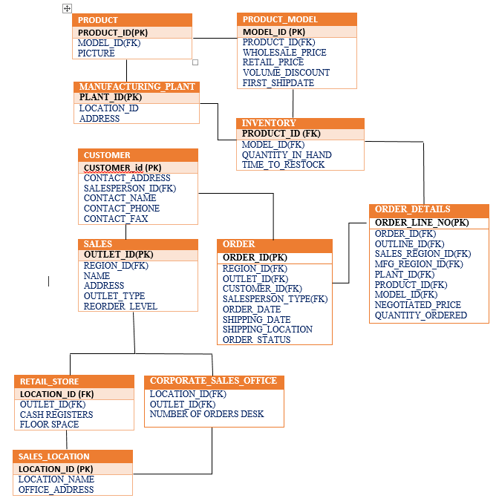

Model flow to presented here...
Required Trace Ability Matrix
SUBJECT AREA | KEY BUSINESS MEASURES | GRANULARITY | DIFFERENT KIND OF ANALYSIS | DIMENSIONS INVOLVED IN ANALYSIS

Physical Design
Data | Standard | Datatype | constraints
MFG_REGION_DIM | REGION_ID | NUMBER | PK
 | NAME | VARCHAR(30)
 | OFFICE_ADDRESS | VARCHAR(60)
MANUFACTURING_PLANT_DIM | PLANT_ID | NUMBER | PK
 | REGION_ID | NUMBER
 | NAME | VARCHAR(30)
 | ADDRESS | VARCHAR(60)
INVENTORY_FACT | REGION_ID | NUMBER | PK/FK
 | PLANT_ID | NUMBER | PK/FK
 | PRODUCT_ID | NUMBER | PK/FK
 | MODEL_ID | NUMBER | PK/FK
 | QTY_ON_HAND | NUMBER
 | REORDER_LEVEL | NUMBER
ORDERS_DIM | ORDER_ID | NUMBER | PK
 | ORDER_DATE, | DATE
 | ORDER_STATUS | VARCHAR(10)
 | CUSTOMER_ID | NUMBER
 | SHIP_LOCATION_ID | NUMBER
 | REGION_ID | NUMBER
 | REQ_SHIP_DATE | DATE
 | PLANNED_SHIP_DATE | DATE
 | SALESPERSON_ID | NUMBER
 | OUTLET_ID | NUMBER
PRODUCT_DIM | PRODUCT_ID | NUMBER | PK
 | MODEL_ID | NUMBER
 | COMPONENT_ID | NUMBER
 | NUMBER_OF_COMPS | NUMBER
 | DESCRIPTION | VARCHAR(60)
 | SUGGESTED_WHOLESALE_PRICE | NUMBER(8,2)
 | SUGGESTED_RETAIL_PRICE | NUMBER(8,2)
 | ELIGIBLE_FOR_VOLUME_DISCOUNT | BOOLEAN
SALES_DIM | REGION_ID | NUMBER | PK/FK
 | OUTLET_ID | NUMBER | PK
 | NAME | VARCHAR(30)
 | ADDRESS | VARCHAR(60)
 | OUTLET_TYPE | VARCHAR(20)
RETAIL_STORE_DIM | REGION_ID | NUMBER
 | OUTLET_ID | NUMBER | PK
 | FLOOR_SPACE | NUMBER(7,2)
CORPORATE_SALES_OFFICE_DIM | REGION_ID | NUMBER
 | OUTLET_ID | NUMBER | PK
 | NUMBER_OF_ORDER_DESKS | NUMBER
 | LOCATION_ID | NUMBER | FK
CUSTOMER_DIM | CUSTOMER_ID | NUMBER | PK
 | CUSTOMER_NAME | VARCHAR(30)
 | CONTACT_PHONE | NUMBER(12)
 | ADDRESS | VARCHAR(60)
 | SHIP_LOCATION_ID | NUMBER
 | SHIP_TO_ADDRESS | VARCHAR(60)
 | BILL_TO_ADDRESS | VARCHAR(60)
ORDER_FACT | SALES_REGION_ID | NUMBER | PK/FK
 | OUTLET_ID | NUMBER | PK/FK
 | ORDER_ID | NUMBER | PK/FK
 | ORDER_LINE_NO | NUMBER | PK/FK
 | MFG_REGION_ID | NUMBER | PK/FK
 | PLANT_ID | NUMBER | PK/FK
 | PRODUCT_ID | NUMBER | PK/FK
 | MODEL_ID | NUMBER | PK/FK
 | NEGOTIATED_PRICE | NUMBER(8,2)
 | QTY_ORDERED | NUMBER

Operational to Dimensional Model - Map:

Map:
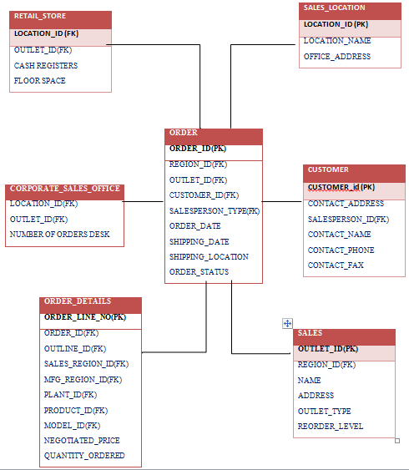

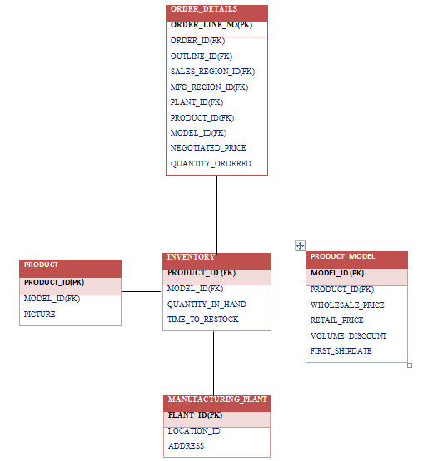

Presented by
Apoorva Singh
Arijit Mukherjee
Kavipriya Mahendhran

